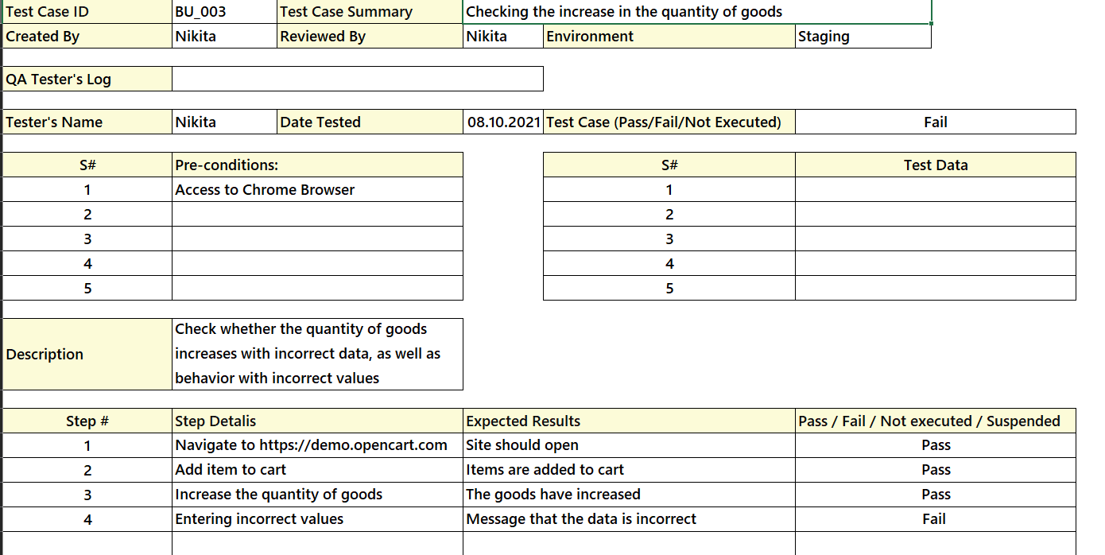

For the third test case, the design technique of equivalent division is used. That is, first allowable values (1, 2,…) are entered, and only then inadmissible ones (negative numbers, letters, signs, just an empty field with a space).